DBMS ASSIGNMENT

TABLES

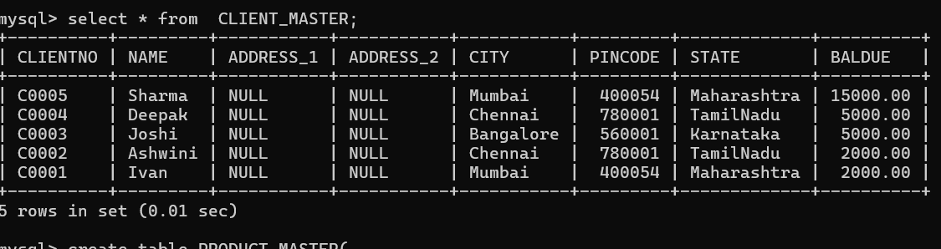

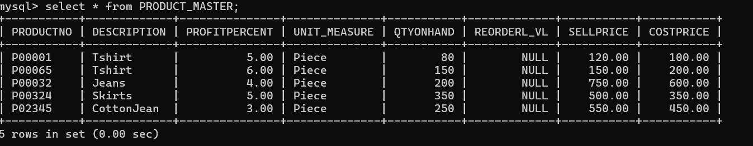

CREATING VIEW USING 1 TABLE

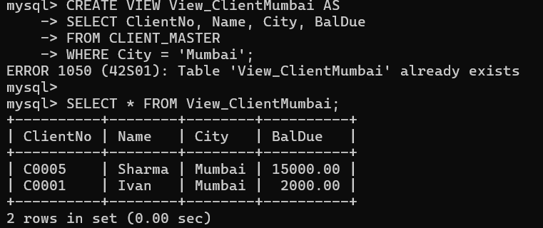

CREATING VIEW USING MORE THAN 1 TABLE

